**GROUP PROJECT, GROUP 3**

**DATE: 6 February 2019**

TIME: **09:30 – 15:00**

***15:00 – 15:45 (lunch)***

**15:45 – 18:00**

**ATTENDEES** Tom Gibbs, Henry Crofts

**LOCATION:** *PROGRAMMING ROOM*

**Minute Taker: Tom Gibbs**

**Overall aims of the current sprint *(Detailed tasks, user stories and time allocations are tracked on JIRA)***

* Work towards final functionality of game manager
* Work towards final functionality of water level manager
* Work towards final functionality of UI manager
* Begin work/design of tutorial level

**Meeting minutes:**

Both members present.

Team members agree that the highest priority remains the completion of reliable manager scripts.

Team began by working on the event manager as this is most crucial to gameplay and will (re)define the necessary functions of the other game managers and potentially events themselves if significant adjustment is made.

Team agree that as always work should be completed within studio jams. Though this week we should hold an additional jam if necessary to ensure all work is completed exclusively within jams because the manager functionalities are of such great importance.

Team spent the 2 hour assigned tasks implementing a game and event manager structure. Though after spending 2 hours on the task the team reviewed progress, finding the work completed was far from completion, inefficient and the changes made to the structure to achieve its functionality would make including the remaining desired behaviours difficult.

Team agreed that the manager should be rewritten with the lessons learned and used JIRA to split 2hours of the reserved task time to continue work on the task.

This implementation was much more successful, though the structure implemented was not optimal for dynamically changing the weighted chance of a random event. Team discussed that 4 hours had now been used to complete this task and more time would be needed to attempt a fix.

Team agree best action is to move on to another task and request a tutor meeting as soon as possible for guidance on how to structure the game and event manager classes.

Email sent to Chris.

*JIRA board updated with times and specific tasks (as well as tasks below) to reflect the changes made to the reserve task to address the above issues.*

Team moved onto updating the water manager and UI manager, which took only marginally longer than expected.

Team are aware of minor potential modifications that may be required later in development, should the design of the event manager be fundamentally overhauled.

Team moved onto reviewing secondary event behaviours. Team confirmed all as expected with the only exception being interaction between the seagull mess and the cannonball.

Team used the whiteboard to plan a solution to the undesirable interactions.

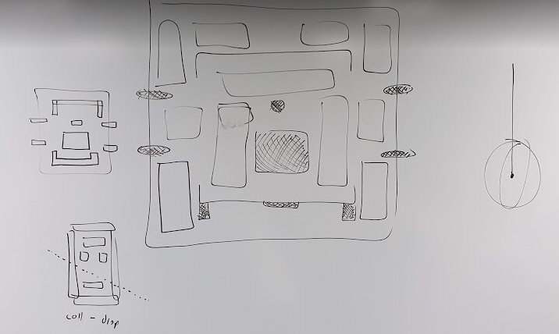

Team agreed amendments:

* Select random x/z position with fixed y value to raycast from.
* Check whether point on deck is ‘available’. If ‘available’ spawn at this position.
* Any result not ‘ShipDeck’ will not be ‘available’.
* Team can then used colliders above map to restrict undesirable impact points.
* If not ‘available’ loop and check for ‘available’ position. If still no ‘available’ position is found, threshold is reached, and the object is spawned.
* If threshold is reached and target position is above bird mess – cannonball impact will always remain/replace bird mess.

Team began implementing this behaviour, confirming it functional before ending the jam.

Team tested this implementation multiple times, across multiple sessions without any imperfect behaviour being displayed.

Meeting ended.

Next jam scheduled for Thursday 07/02/2019 @ 11:00.

***Detailed tasks, task descriptions, user stories and time allocations are tracked on JIRA.***

**Tasks for the current week:**

**Tom (12 Hours):**

* **To be completed as part of studio jam, Ensure Event Manager Works Correctly (2h)**

Ensure that the event manager handles the Dictionary correctly holding which events are currently active and removing them correctly from the Dictionary.

* **To be completed as part of studio jam, Ensure Water Level Manager Works Correctly (2h)**

Team should work together to ensure that the water level manager works correctly ending the level when the water level is too high, also raising and lowering the water as required.

* **To be completed as part of studio jam, Ensure UI Manager Works Correctly (2h)**

As a team check that the UI manager works correctly showing the correct events. Spend time fixing any issues with linking into the event manager.

* **To be completed as part of studio jam, give each activity a duration property (30m)**

Team members must work together to ensure a shared understanding for the remainder of development.

Completed task should associate a time with completion of each hazard/task. This should be visually represented by the active players UI indicator. All variables must be exposed in the unity editor for rapid future amendments.

* **Reserved task time, will be split task to be allocated during sprint (2h remaining after adjustments below)**

Task to be subdivided into specific tasks once highest priority tasks have been completed.

Team believe manager tasks may overrun anticipated assigned times. All remaining time will be used to address remaining priority issues.

**Reserved task time broken into (tasks also specified within JIRA sprint):**

* **To be completed as part of a studio-jam, review, amend and implement event manager (2h 30m)**
  + Team have found implementation of this manager and it’s interaction with existing managers troublesome. Task used as extension to existing task to continue work on manager.
* **To be completed as a team, seek tutor advice to restructure event manager (30m)**
  + Request meeting with programming lecturer to discuss current implementation and logic of event manager.
* **To be completed as part of a studio-jam, use tutor advice to restructure event manager (1h)**
  + Using feedback from programming tutor meeting, amend existing event manager implementation to allow for dynamic weighting of events.

**Henry (12 Hours):**

* **To be completed as part of studio jam, Ensure Event Manager Works Correctly (2h)**

Ensure that the event manager handles the Dictionary correctly holding which events are currently active and removing them correctly from the Dictionary.

* **To be completed as part of studio jam, Ensure Water Level Manager Works Correctly (2h)**

Team should work together to ensure that the water level manager works correctly ending the level when the water level is too high, also raising and lowering the water as required.

* **To be completed as part of studio jam, Ensure UI Manager Works Correctly (2h)**

As a team check that the UI manager works correctly showing the correct events. Spend time fixing any issues with linking into the event manager.

* **To be completed as part of studio jam, give each activity a duration property (30m)**

Team members must work together to ensure a shared understanding for the remainder of development.

Completed task should associate a time with completion of each hazard/task. This should be visually represented by the active players UI indicator. All variables must be exposed in the unity editor for rapid future amendments.

* **Reserved task time, will be split task to be allocated during sprint (2h remaining after adjustments below)**

Task to be subdivided into specific tasks once highest priority tasks have been completed.

Team believe manager tasks may overrun anticipated assigned times. All remaining time will be used to address remaining priority issues.

**Reserved task time broken into (tasks also specified within JIRA sprint):**

* **To be completed as part of a studio-jam, review, amend and implement event manager (2h 30m)**
  + Team have found implementation of this manager and it’s interaction with existing managers troublesome. Task used as extension to existing task to continue work on manager.
* **To be completed as a team, seek tutor advice to restructure event manager (30m)**
  + Request meeting with programming lecturer to discuss current implementation and logic of event manager.
* **To be completed as part of a studio-jam, use tutor advice to restructure event manager (1h)**
  + Using feedback from programming tutor meeting, amend existing event manager implementation to allow for dynamic weighting of events.

***Explanation of Task Split on JIRA.***

1. Select the group project from the dropdown menu.
2. Once the project is selected proceed to the backlog where you can see the current sprint and all issues in the backlog.
3. Right click on the issue that has been assigned for contingency in this case the task L6G3–260 and L6G3–261 both named *“To be completed as part of a studio jam, depending on the situation of the project once all other tasks have been completed. As a team assign new tasks and split this task up accordingly”*
4. From the dropdown menu that appears, select “*split issue”* this will then present you with another menu where you can change the task into other tasks without adjusting the scope of the sprint. (provided the number of hours remains the same).

